Semi-Autonomous Method for Bulk Fault Slip Rate Analysis

Franklin Wolfe

Department of Earth and Planetary Sciences, Harvard University

Contact: wolfe_franklin@g.harvard.edu

Dec 2018

Synopsis: The directions below describe how to create profiles across multiple fault scarps imaged with digital elevation data, and subsequently run a series of analyses to determine the slip rate of the faults in question. The data outputs will be Line and Point Feature Classes that can be uploaded into an ArcGIS program to visualize the spatial distribution of fault slip rates and strain. Numerous subsets of data can be analysed simultaneously if there is a desire to create separate output files (ex: different data collection methods, age constraints, data locations, etc.).

The following codes have been modified and based on the work of Tim Stahl (University of Canterbury, Department of Geological Sciences) and Biljana Lukovic (GNS Science, GIS Specialist), and in collaboration with them. There are five steps:

1. Profile Selection in ArcGIS 10.5.1.7333
2. Profile Data Extraction in Python 2.7.13
3. Fault Scarp Analysis GUI in Python 3
4. Slip Statistics Calculation in Matlab 9.4.0.813654
5. Profile Upload to ArcGIS in Python 2.7.13

Please contact [wolfe_franklin@g.harvard.edu](mailto:wolfe_franklin@g.harvard.edu) for questions or additional information.

__________________________________________________________________________________

1. Profile Selection in ArcGIS:

* You must have a geologic layer file with ages and elevation model
* Go to the Catalogue Tab:
  + New File Geodatabase (right click on folder where you want to put it)
  + New Feature Class (right click your new Geodatabase)
    - Give Name
    - Type: Line Features
    - Pick Coordinate System:
      * Projected Coordinate System (for NZ): NZGD_2000_New_Zealand_Transverse_Mercator
* Table of Contents: Layers:
  + Right click on your new Line Feature Class
    - Select Edit features then start editing. Click continue on prompt of ‘warnings’.
    - Get the Editor Tool Bar from Customize->Toolbars->Editor
    - Create Features Icon
    - Click on your new Line Feature Class in menu to the right
    - Click line below in Construction Tools
    - Draw line and double click to finish
    - When you are finished, select Editor (drop down feature from Editor Toolbar), Save Edits, Stop Editing.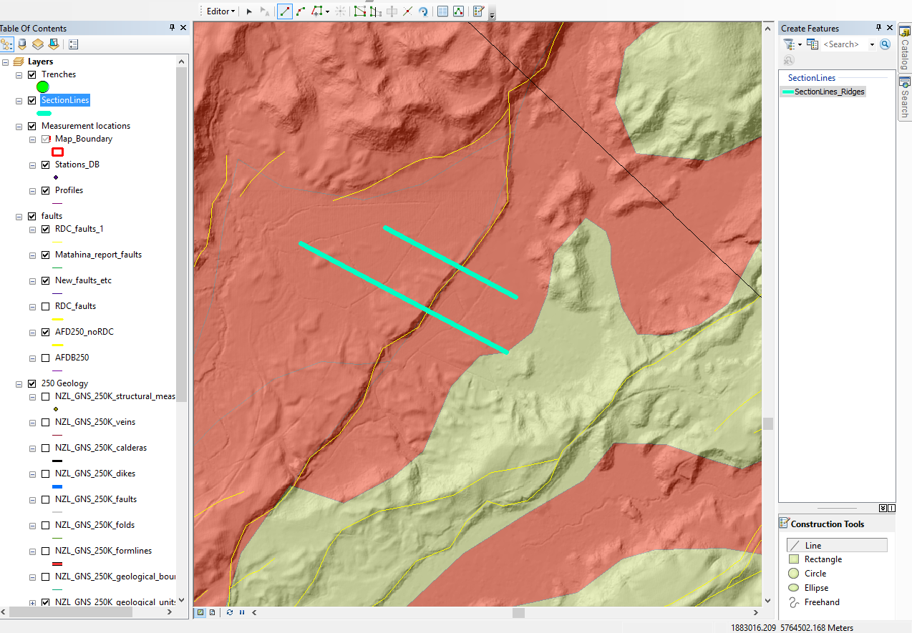
* The Section Line Feature Class must have a “SectionID” field. This is a field that must be added manually to the attribute table. To do this, open the attribute table, add field titled “SectionID”, and then run an operator on the new “SectionID” field to populate this field with the values of the “ObjectID” field. The operator tool is called the “Field Calculator” tool. You will see that when you open this tool, a blank dialogue box appears. You also see the beginning of a calculation right above. Fill in the rest of the calculation then hit OK. The rest of the calculation is just “= ObjectID”. You will only be able to undo your edits if you are in an edit session, so to be cautious, do this before you “stop editing”.
* If you do not have age data, you will need to add these columns as well so that there are no errors in the Matlab code. You can ignore the output for rates, but the slip displacements will still be consistent. Add one column named "AGE_Max" and populate it with a larger value than a second column you create called "AGE_Min"

1. Profile Data Extraction in Python:

* The script “createProfilesFiles4_Harvard.py” creates points along section lines drawn in the previous step at equal intervals. It extracts elevation data and geologic age, and exports these data into separate .csv files for each section line. It also creates a new Point Feature Class for the points along the section.

Within the createProfiles4_Harvard.py script:

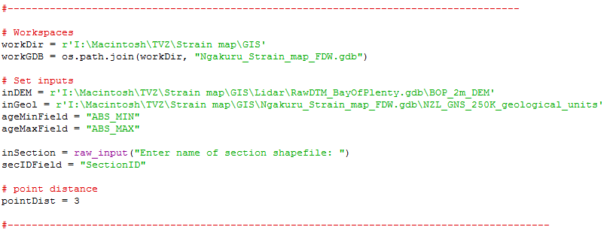

* + Change the workDir (working directory) to the folder that contains the geodatabase and where you want your output files to be placed.
  + Change the workGDB to the name of your newly created geodatabase. This is the one that contains the feature class lines and points created in GIS.
  + Change inDEM to the location of the DEM.
  + Change inGeol to the location of the geologic map layer with ages.
  + Set ageMinField and ageMaxField to the given names for these layers within the geologic map layer.
  + Change secIDField to “SectionID”. This is the name that was created for this field previously.
  + Set the point distance to the profile density you want to create. This value is in meters. For example, if you choose 10, the program will take a distance and elevation point along the profile every 10 meters. There is a trade-off between density and time. 10 seems to work well. For smaller scarps, you may need to change this to 1 meter.
  + When you run the code, it will prompt you to fill in a name for which sections you would like to run. This is the name of the GIS feature class.



* + The code will create a csv file for each section line and put each file into a folder called “Outputs_(name of your Line Feature Class)”. It will also create a file of points at the point distance spacing given.
  + The outputted csv file will have four columns: X, Z, age min, and age max.

1. Fault Component Selection

* In this part of the analysis, you will manually select the data to represent the Hanging wall, Footwall, and Scarp for each profile. This process will be completed on each of the csv files in the previous step.
* The program of choice for running this section of the code is Jupyter Notebook, which can be downloaded online free by downloading Anaconda <https://www.anaconda.com/download/#windows>
* Launch the Jupyter notebook script called ‘FaultScarp_Calculator_Wolfe_GNS.ipynb’
* You will need a few packages that might not come already installed. You can install these easily within the Anaconda Prompt Window.
  + Type the following (followed by an enter command)
    - pip install setuptools
    - pip install msgpack
    - pip install qgrid
* Make sure that the working directory is set to the location of the folder that contains the csv files. You can check this by typing ‘ls ‘and entering. If it is not, you can navigate to that folder by typing ‘cd “subfolder in current location”’. Or by typing ‘cd ..’ to step back one folder level.

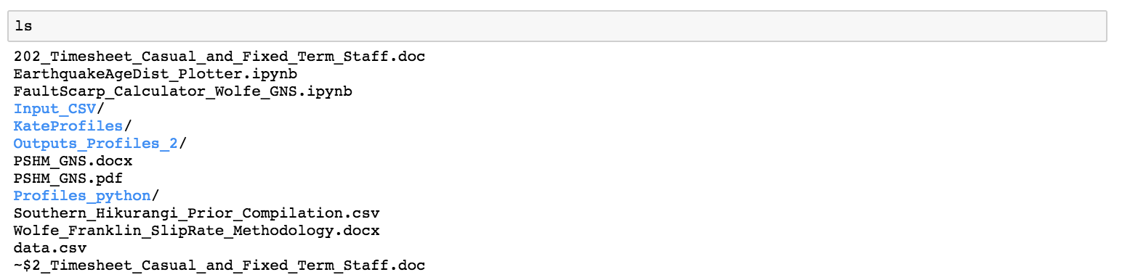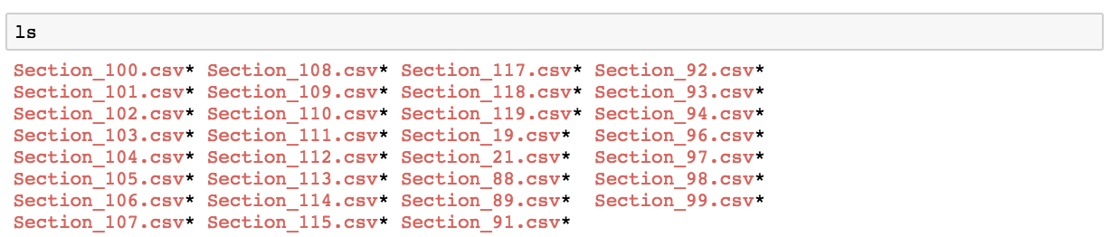

* These are the output csv files from the previous step.
* The data variable must contain the name of the csv file you want to analyse. This is the only line that you will need to change when analysing different csv files.

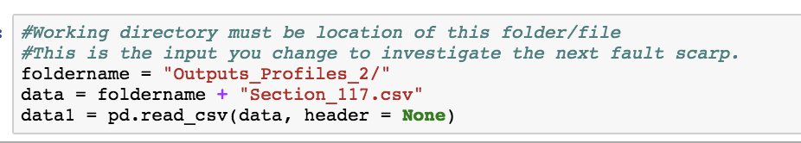

* Run the next box to call the widget.
* Run the next box to display the plot.
* Run the next box to initialize the data manipulation capabilities.

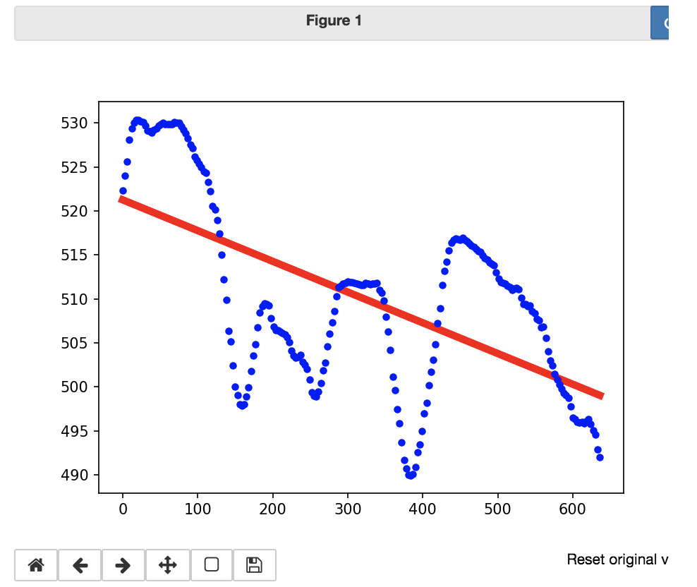

* Manipulate and filter the data to fit the red line to the surface you believe represents the footwall. You can do this by flicking the filter button at the top of each column and then sliding the bar to only contain data within the range you would like to view.

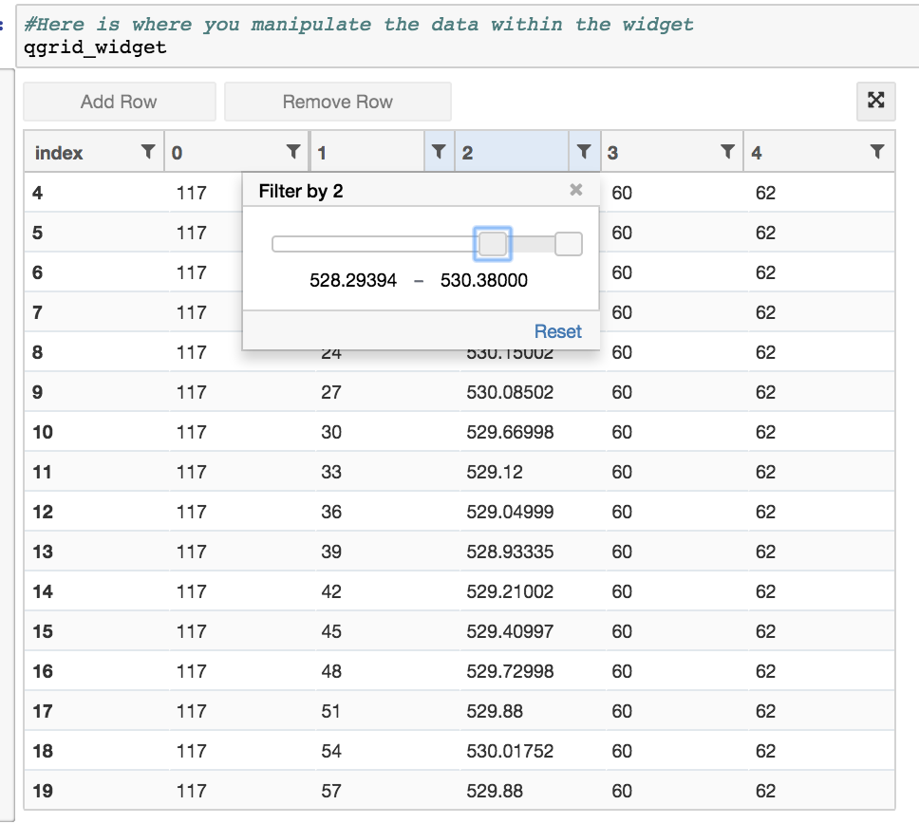

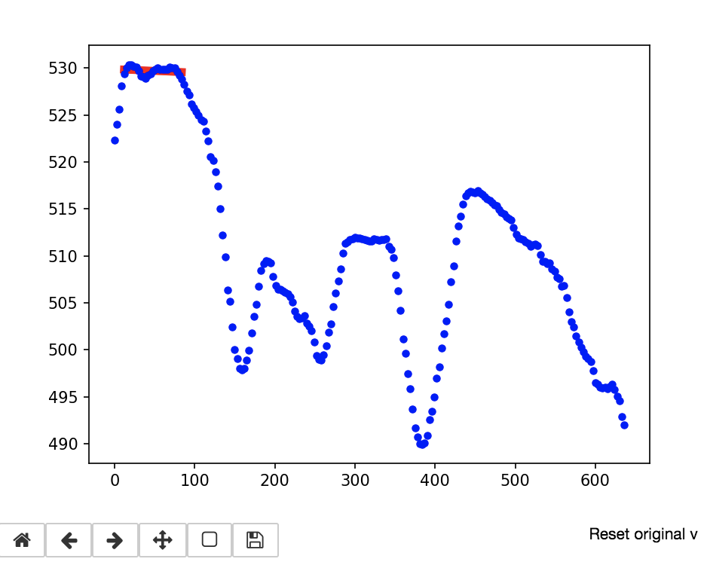

* Once you have made your selection, run the box that saves the data within the FW variable. It is important to not run the HW and SC boxes until you have completed a similar process for each.
* Next, run the previous process for the hanging wall. You can remove you previous filtered selection by clicking the filter button on the row and then selecting reset.

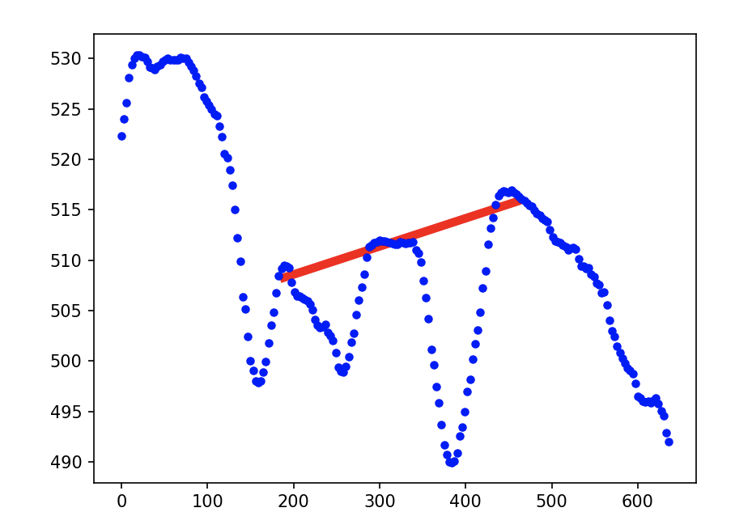

* Now run the HW box.
* Do the same for the Scarp.

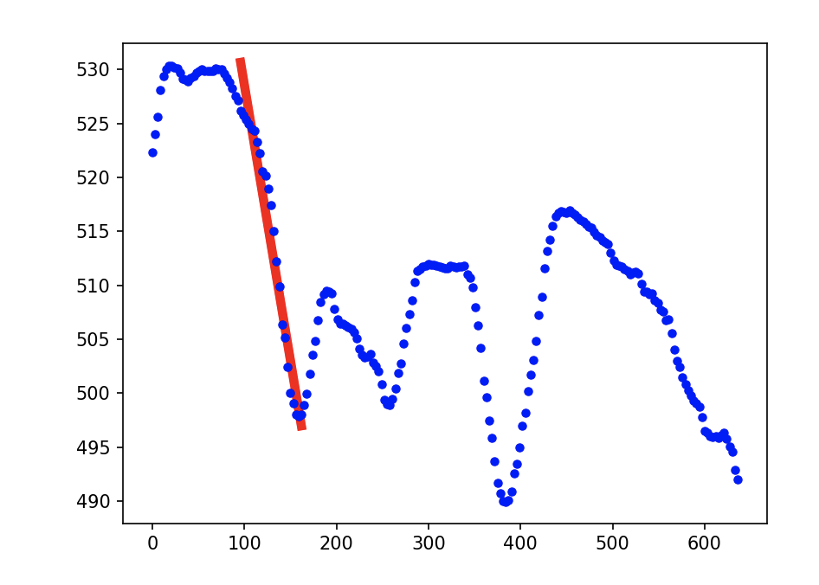

* Run the SC box.
* The next box will allow you to ‘see’ the choices you have made before saving them into a new csv file. Run the box.

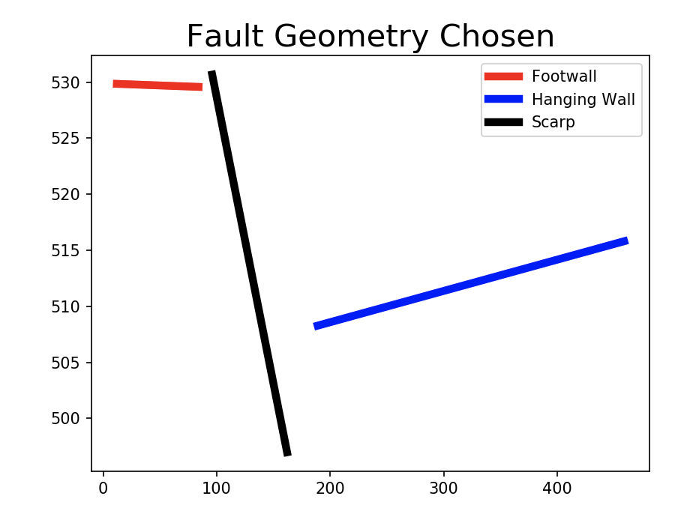

* This is a simplified representation of what you have chosen. If you like the selection, run the next box to save the file.
* The file will be saved within the same folder, but will have the title ‘processed’ infront.

1. Slip Statistics Code in Matlab:

* The matlab script “mcslip_sliprate_harvard.m” will allow you to calculate slip statistics from the input csv files and a fault geometry. The code loops through subfolders of the parent directory and outputs a separate csv file of slip statistics for each section line within the subfolders.
* The code allows for numerous fault, hanging wall, footwall, and scarp geometries, as outlined in *Appendix A: Slip Rate Calculation for an Offset River Terrace from Thompson et al. (2002).* See this appendix for a complete description of the methodology/geologic context for the code. *Appendix C* provides an explanation of the slip distribution methodology and uncertainty if you wish to display histograms of the slip distribution for each fault. If there is a point age estimate, you can use this methodology to calculate a slip rate distribution. Given that the age data in the default version of this code rely on a maximum and minimum age, the default output is a slip rate range as opposed to a distribution. However, the slip rate range is derived from the slip distribution.

Thompson, S. C., R. J. Weldon, C. M. Rubin, K. Abdrakhmatov, P. Molnar, and G. W. Berger, Late Quaternary slip rates across the central Tien Shan, Kyrgyzstan, central Asia, J. Geophys. Res., 107(B9), 2203, doi:10.1029/2001JB000596, 2002.

* Section 0:

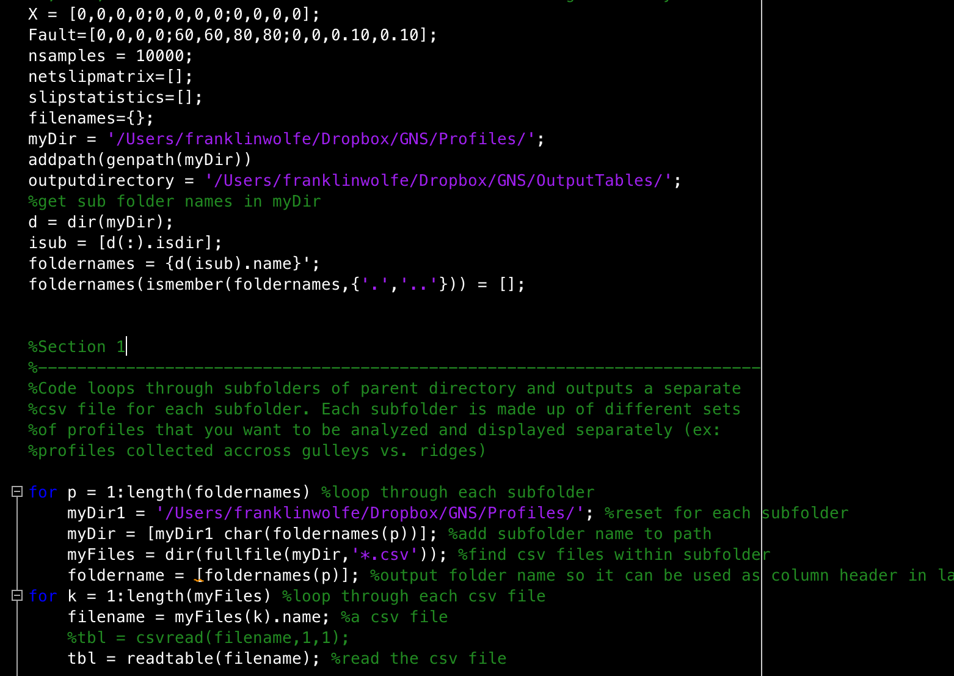

* + Change the “Fault Variable”. If you do not know the true geometries of your faults, you should only place values in the second and third row. Leave the first row as all zeroes. For high angle faults, your values for row 2 might be: [60, 60, 80, 80] which represent the full range of fault dip angles from 60 to 80 degrees with a uniform distribution. The third row represents the position within the fault scarp (as a percentage), in which the fault intersects. For example, if you think the fault intersects the scarp at its base, you may put [0, 0, 0.10, 0.10] as values to represent the fault intersecting within the lower 10 percent of the fault scarp with a uniform distribution.
    - Fault is a matrix arranged as follows:
      * Row 1: Dip mean, Dip deviation, Position mean, Position deviation
      * Row 2: Dip min, max1, max2, end (trapezoidal distribution of dips)
      * Row 3: Position min, max1, max2, end
  + Change the nsamples to the number of iterations or sample size you want the code to run through for each section line. The larger the number, the more precise the statistic, but the longer the code takes to run.
  + Change myDir to the location of the folder where all of the updated csv files for each section line are located.
  + Change outputdirectory to the name of the folder that you created to house the csv files of slip statistics that will be created by the code. For this to run seamlessly with the attachStatistics_azi.py code, make the name of this folder “InputStatistics”.
* Section 1:
  + Change myDir1 to the location of the folder where all of the updated csv files for each section line are located. This is the same as myDir.
* Clear your workspace by typing “clear all” into the Command Window.
* Run the code.
* The new csv files with slip statistics for each section line csv file combined into one csv file will be created and can be found in the outputdirectory you designated.
* On occasion, some of the csv files may not work in the code. If the code fails, enter “filename” into the command line to figure out on which file the code failed. Delete this file, or investigate what might be wrong. It is likely that there is some confusion with how the hanging wall, footwall, and scarps were selected. To check quickly, just delete the files that don’t work, but make a note of where the section lines are located in space so that you can repeat the process and make new lines in those locations to fill in the empty spots on the map.

1. Profile Statistics Upload to ArcGIS

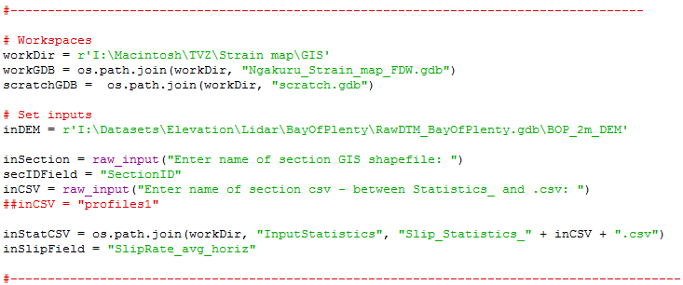

* The attachStatistics_azi4_Harvard.py script will create new Line and Point feature classes so that the output can be displayed in a GIS environment. The slip statistics will be embedded in these feature classes and can be added to the GIS Environment of Layers. The code will also vectorise the average slip rate statistic for each section line into its North-South and East-West components, and create new data field entries for these fields.
  + Change workDir to your working directory that houses the InputStatistics folder. This is the folder that contains the slip statistics csv files created with the mcslip_loop_folders.m script.
  + Change workGDW to the database that contains the Section Lines Feature Class in GIS.
  + Set inDEM to the file path for the elevation model.
  + Set secIDField to “SectionID”.
  + The inputs to inStatCSV should be workDir, the name of your folder that contains the slip statistics csv files created with the earlier script – probably “InputStatistics” (you need the quotation marks), the “Slip_Statistics_” (the root of file names in the output table that doesn’t change despite how many different files you have) + inCSV + “.csv”).
  + The Outputs are the names of the feature classes that will be created by the script.
* When you run the code, it will ask you to input two things:
  + The name of the file you want to analyze. This is the name of the csv file that contains the section lines you want to analyze from the InputStatistics folder. This is the name of the file and does not include “Slip_Statistics_” or “.csv”
  + The name of the GIS shapefile. This is the same input as for the code in step 2.
  + 
* Lastly, add the new data layers to your GIS workspace to display the data.
* If the code does not work, it is likely because these files are already open in the GIS workspace. This might happen if you change something and want to run the script again on the same file names. You must delete the previous files before you can create them again.

1. To show only these new layers, turn off the display of the Section Lines you initially drew in step one. You can play with the attributes to decide on the best output display you want, including which data field you want to show.
2. Profile Statistics Upload to ArcGIS

* The code will generate a field that will allow you to display the slip direction on each profile. To do this, enter the properties feature of the point feature class that you created. Click on the Symbology tab. Click on the Symbol. Click Edit Symbol. Add a layer. Change the Type to Character Marker. Choose ESRI North. Arrow number 109. Now, click Advanced. Rotation. Select ArrowDir as the field to rotate points by.

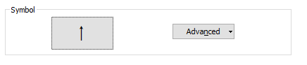

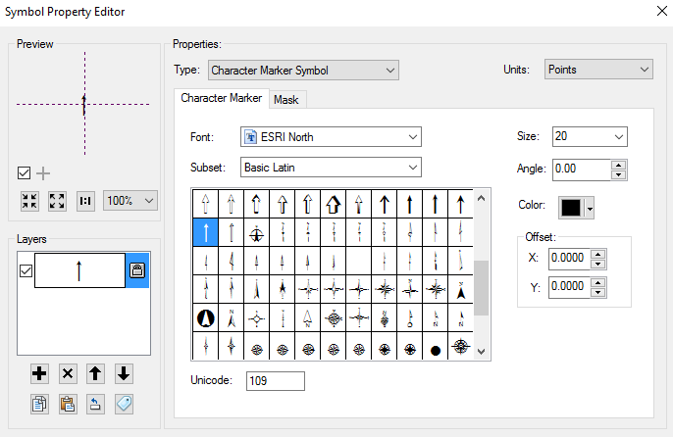

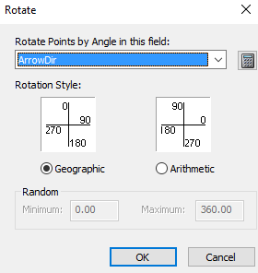

PLEASE CONTACT FRANKLIN WOLFE ([WOLFE_FRANKLIN@G.HARVARD.EDU](mailto:WOLFE_FRANKLIN@G.HARVARD.EDU)) WITH ANY QUESTIONS. PLEASE UNDERSTAND THAT THIS IS A BETA VERSION AND MEANT TO BE A WORKING DOCUMENT. IT WILL BE IMPROVED AND HOPEFULLY YOUR INSIGHT WILL HELP CONTRIBUTE TO A USEFULL CONTRIBUTION! BEST OF LUCK!